**DOCUMENTATION FOR SCENARIO-3:**

**What is Scenario-3?**

* **Alice is a user of the WINGS WORKFLOW SYSTEM.**
* **Alice created a workflow for Converting an html file to text file.**

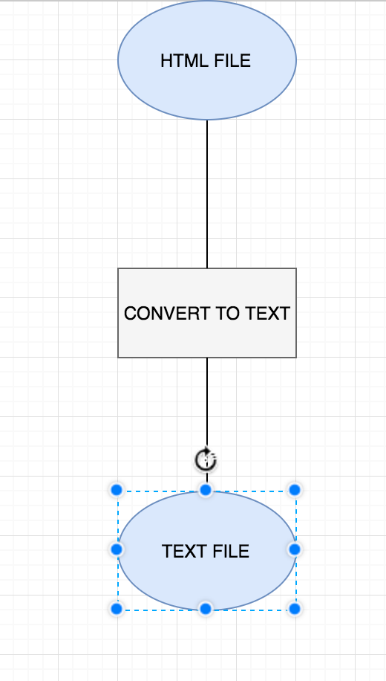

* **Alice, wanted to extend this workflow to create a sorted text file. So now, she modifies this existing workflow to a different one.**

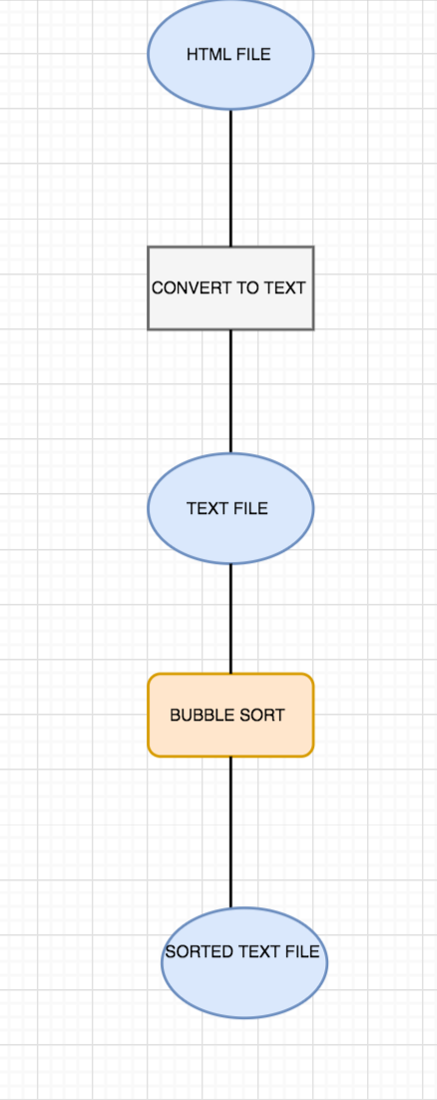

* **When Alice creates this new workflow, it should be noted that the workflow is a revision of her previous workflow and hence we should link them together.**

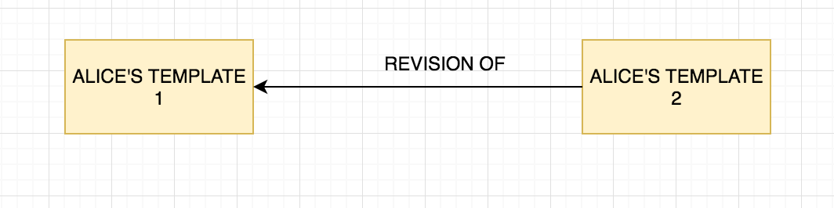

**Important Aspects about the code:**

* **We are creating a signature for the abstract template that will determine the uniqueness of the template with its parameters, data vars, outputs, components and all other links.**
* **This hashed version of the signature helps us identify uniqueness among templates.**
* **Further, we have now exported an issued time property in the abstract template export in OPMW.**
* **This will help us identify changes in current templates have occurred when exactly.**
* **We use this factor for determining which template is going to be a revision of which one here.**
* **This was taken into effect as compared to the last modified time, since it is not correctly exported in the WINGS template from WINGS. (It can be only used for date changes BUT NO TIME CHANGES)**

**VALIDATION TEST EXPECTATIONS:**

* **Let’s say we have created a repository for the templates we have published, but it’s empty initially.**
* **Now, we are publishing are first template with one component (Bubble-Sort).**
* **We have published this workflow and it appears in our repository.**
* **If we go to publish this same workflow again, we will be warned about the fact that we already have published this same workflow and hence it does not publish this workflow again, since nothing has changed since the last published workflow.**
* **Now, if we change this workflow by adding another component (SEARCH), then we will also require that a new workflow should be published. A new workflow gets published and we will also be able to link it to the latest one that existed, from which this change has taken place. This will be due to the time factor that we have maintained (issuedTime).**